**<SPARK AIRWAYS>**

**HLD**

**Version 1.0**



|  |  |  |  |
| --- | --- | --- | --- |
|  | **Prepared By / Last Updated By** | **Reviewed by** | **Approved By** |
| **Name** | <POD to fill>  Bhavesh Saini  Abhay Raj Singh  Nikhil Kharwal  Siddharth Sharma  Anshuman Sahu | <Trainer/Project Governance Representative/Cohort Mentor to fill> | <Trainer/Project Governance Representative/Cohort Mentor to fill> |
| **Role** |  |  |  |
| **Signature** |  |  |  |
| **Date** |  |  |  |

**Table of Contents**

**1.0** **Purpose of this document 4**

**2.0** **Business Case 4**

**3.0** **Appendices 4**

**3.1** **Glossary 4**

**3.2** **Other 4**

**4.0** **Terms & Conditions 5**

**5.0** **Change Log 5**

# Purpose of this document

This document provides an overview about the business need and the solution that can be provided to fulfil the objective.

# Business Case

<POD to fill>

# HLD (High Level Diagram)

## E-R Diagram

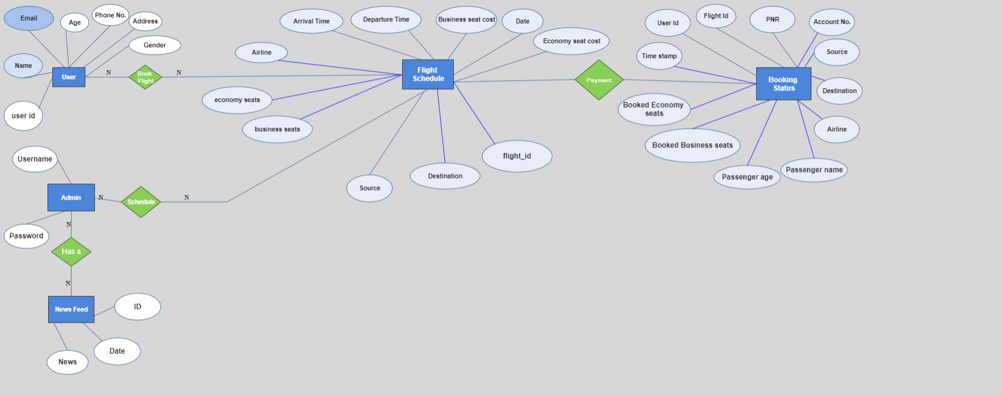

## Database Tables

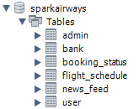



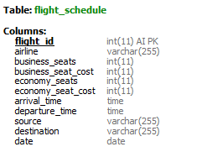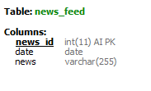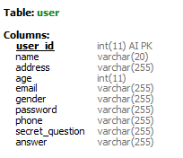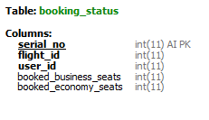

## 3.3 UseCase Diagram

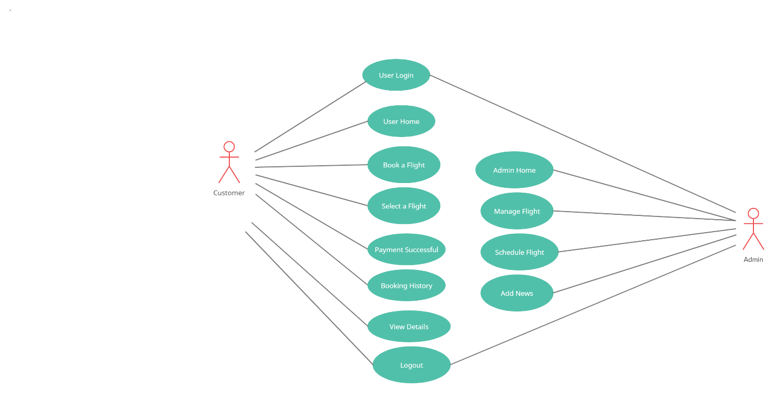

## 3.4 Data Flow Diagram

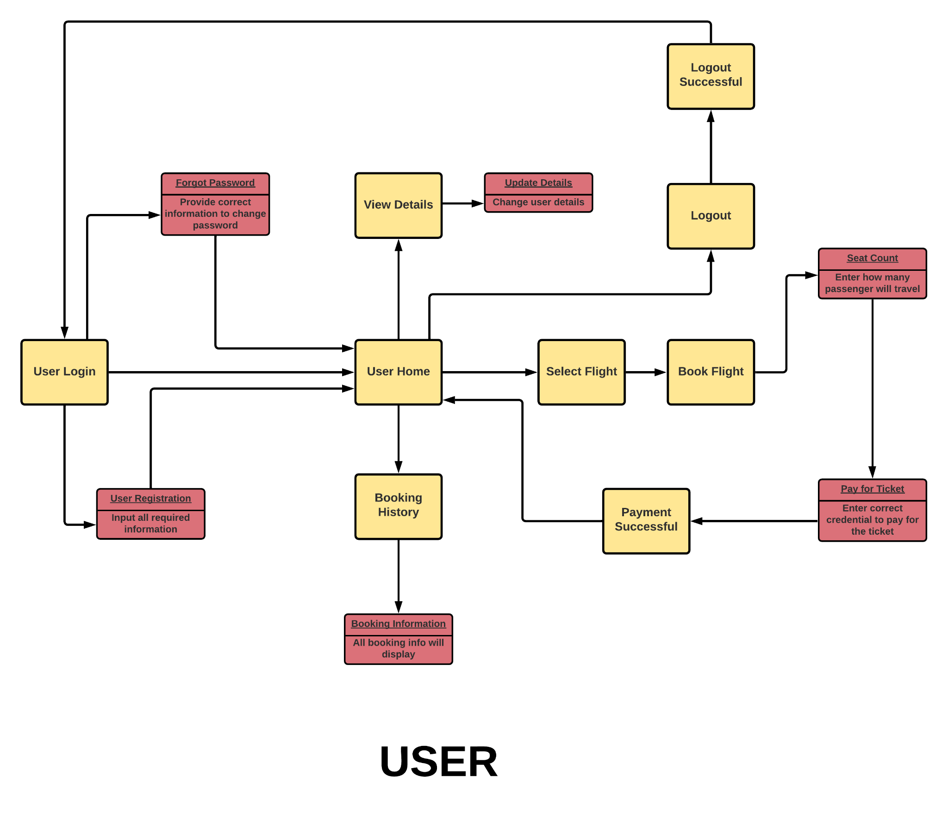

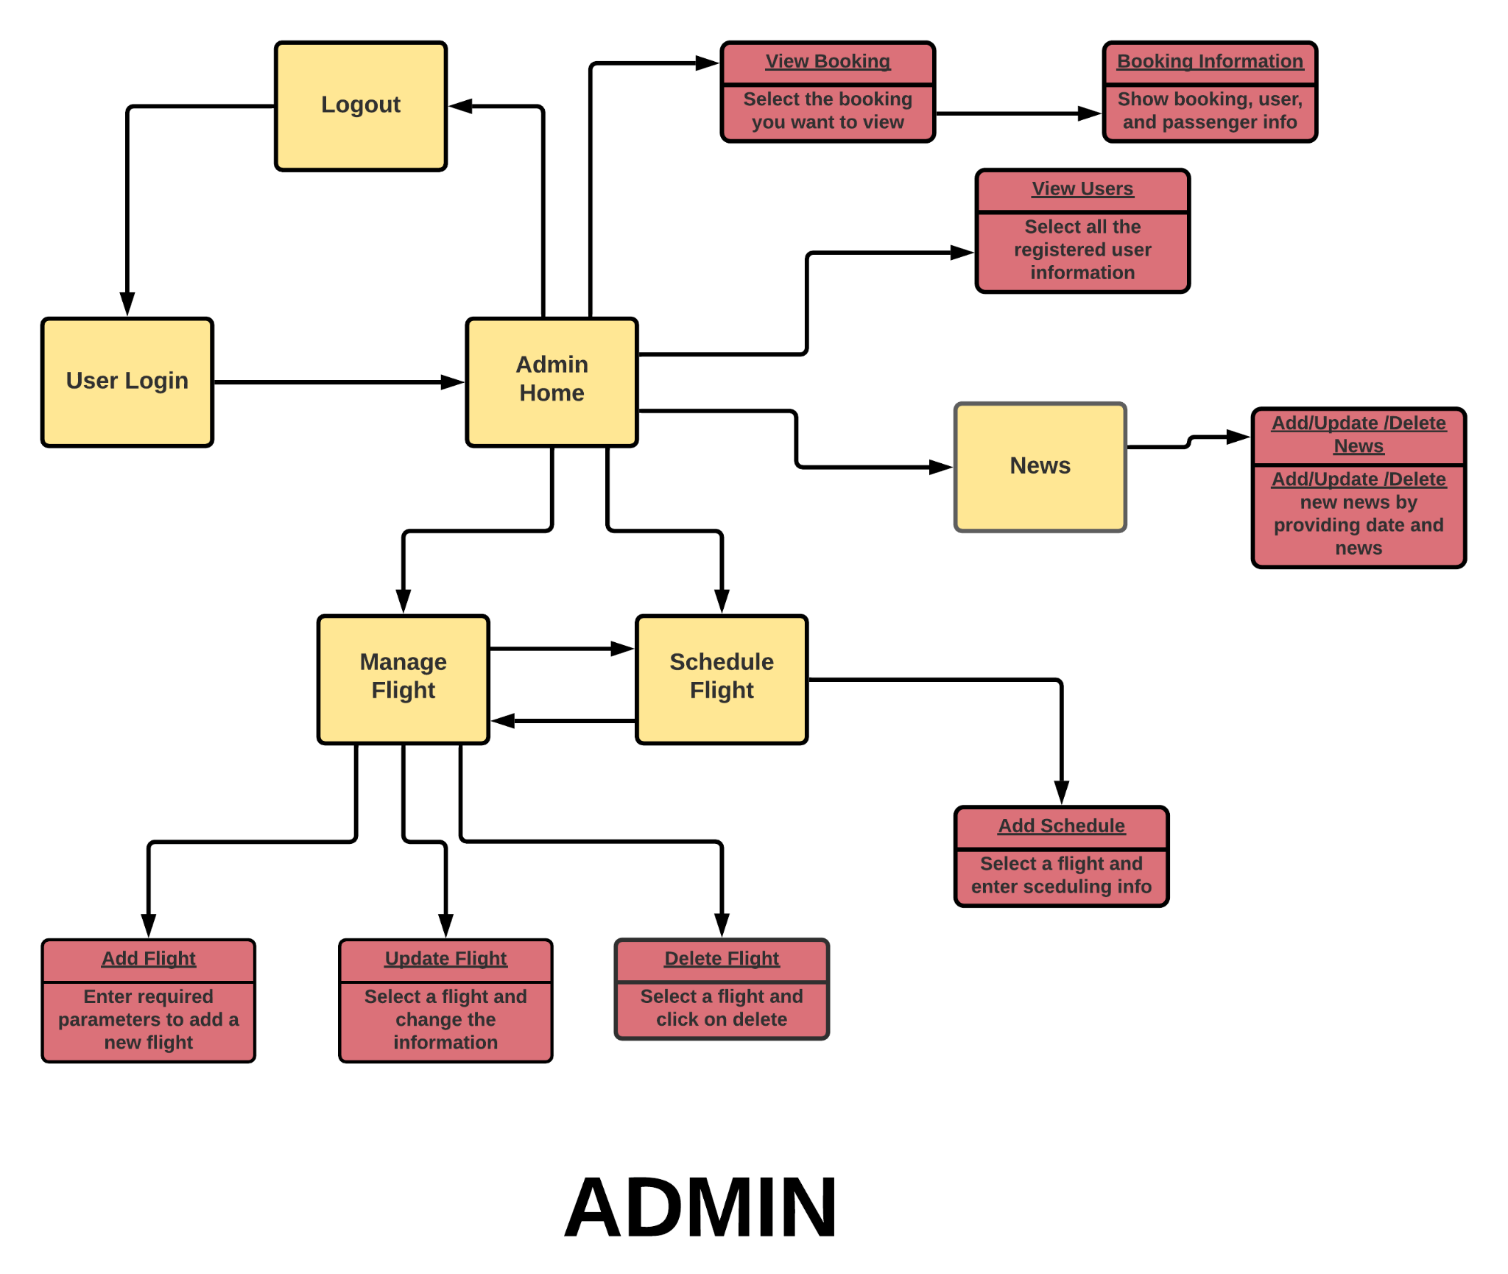

## 3.5 Class Diagram

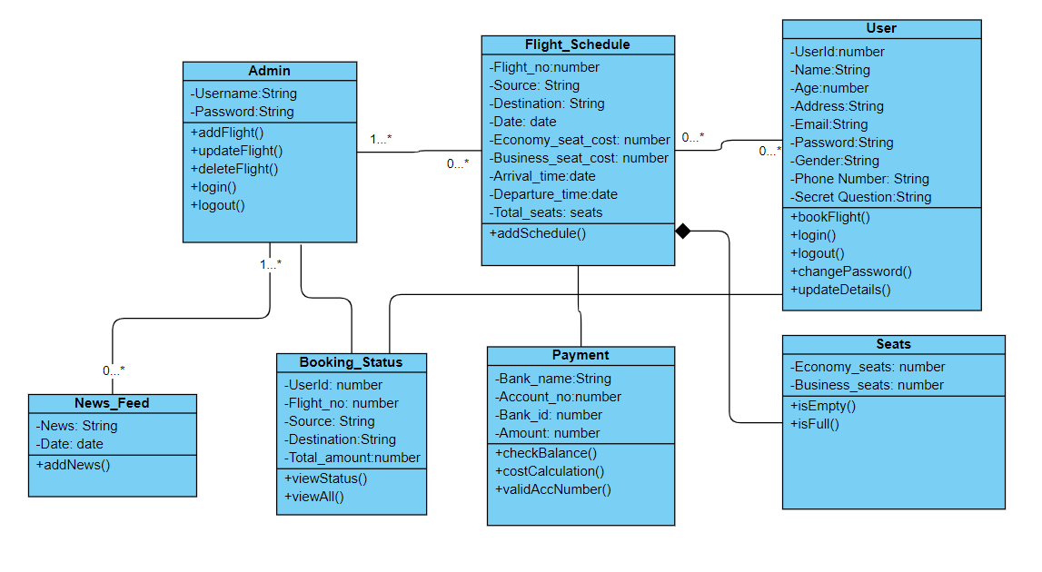

## 3.6 Service Diagram

